**DAY 11: MORNING ASSESSMENT**

1. How do you read a CSV file and display the first 10 rows?

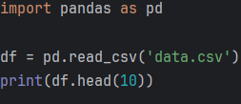

Output:

Name Age Department Salary

0 Alice 28 HR 55000.0

1 Bob 35 Engineering 72000.0

2 Charlie 25 Marketing 48000.0

3 David 40 HR 61000.0

1. How do you find the number of rows and columns in a DataFrame?

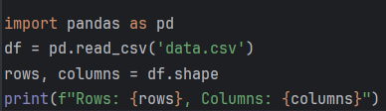

Output:  
Rows: 10, Columns: 4

1. Given a DataFrame df, how do you display only the rows where age > 25?

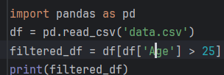

Output:  
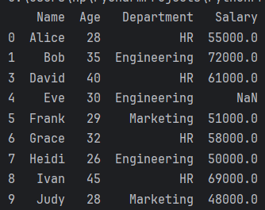

1. Replace all missing values in column salary with the **mean salary**.

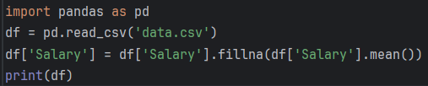

Output:  
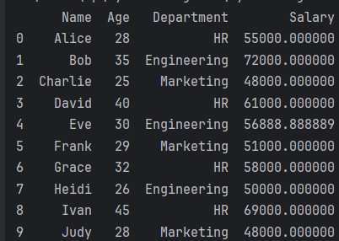

1. How do you rename the column emp_id to employee_id?

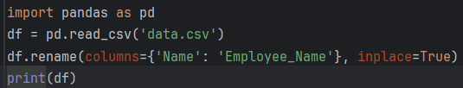

Or  
df.rename(columns={'emp_id': 'employee_id'}, inplace=True)

Output:  
Employee_Name Age Department Salary

0 Alice 28 HR 55000.0

1 Bob 35 Engineering 72000.0

1. How to drop duplicate rows in a DataFrame?

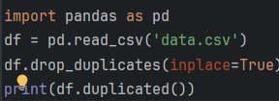

Output:  
0 False

1 False

2 False

3 False

4 False

5 False

6 False

7 False

8 False

9 False

dtype: bool

1. How do you convert a column of string dates "2023-05-01" into datetime format?

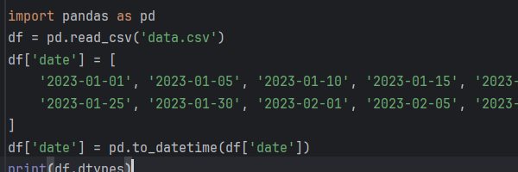

Output:  
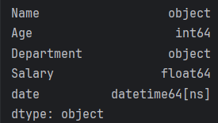

1. How to group a DataFrame by department and find the total salary for each?

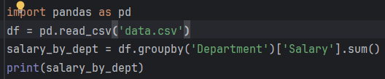

Output:  
Department

Engineering 122000.0

HR 243000.0

Marketing 147000.0

Name: Salary, dtype: float64

1. How do you sort a DataFrame by date in descending order?

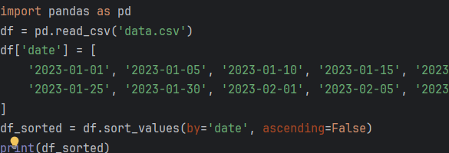

Output:  
 Name Age Department Salary date

9 Judy 28 Marketing 48000.0 2023-02-10

8 Ivan 45 HR 69000.0 2023-02-05

7 Heidi 26 Engineering 50000.0 2023-02-01

6 Grace 32 HR 58000.0 2023-01-30

5 Frank 29 Marketing 51000.0 2023-01-25

1. Create a new column total_marks by adding three columns: math, science, and english.

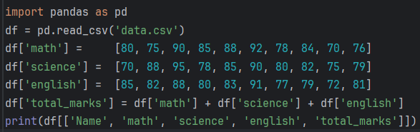

Output:  
 Name math science english total_marks

0 Alice 80 70 85 235

1 Bob 75 88 82 245

2 Charlie 90 95 88 273

3 David 85 78 80 243

4 Eve 88 85 83 256

1. How do you filter rows where column score is between 40 and 80?

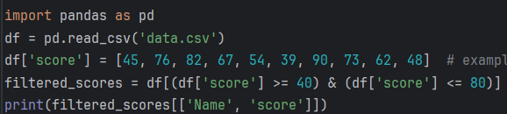

Output:  
 Name score

0 Alice 45

1 Bob 76

3 David 67

4 Eve 54

7 Heidi 73

8 Ivan 62

9 Judy 48

1. Display the top 3 rows with the highest values in column sales.

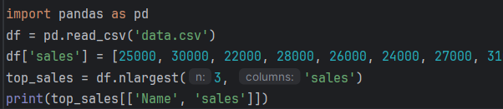

Output:  
 Name sales

7 Heidi 31000

1 Bob 30000

8 Ivan 29000

1. Find the average, min, and max of the price column using a single function.

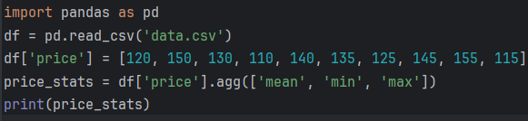

Output:  
mean 132.5

min 110.0

max 155.0

Name: price, dtype: float64

1. How to set a column (e.g., date) as the index of a DataFrame?

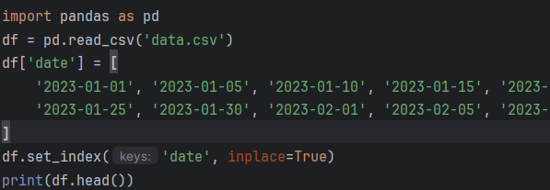

Output:

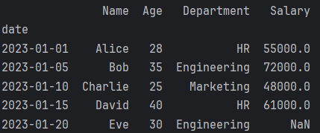

15. Convert a categorical column gender (with values M/F) into numeric using mapping (M → 1, F → 0).

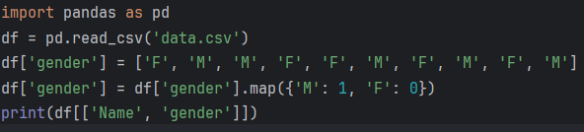

Output:  
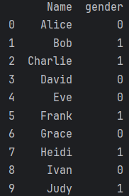

**NumPy Questions**

1. Create a 1D NumPy array from 0 to 9.

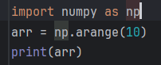

Output:  
[0 1 2 3 4 5 6 7 8 9]

1. Create a 3x3 NumPy array filled with random integers between 1 and 100.

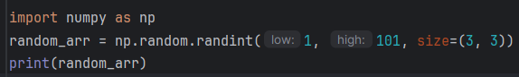

Output:  
[[37 63 39]

[77 69 83]

[46 2 25]]

1. How do you find the mean and standard deviation of a NumPy array?

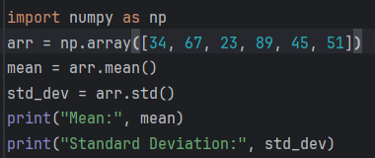

Output:  
Mean: 51.5

Standard Deviation: 21.631381524689232

1. Given an array, replace all values greater than 50 with 50.

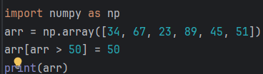

Output:  
[34 50 23 50 45 50]

1. Create a NumPy array and reshape it from 1D to 2D (e.g., 12 elements → 3x4).

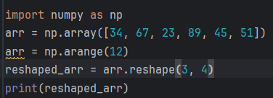

Output:  
[[ 0 1 2 3]

[ 4 5 6 7]

[ 8 9 10 11]]

1. Find the number of even numbers in a NumPy array.

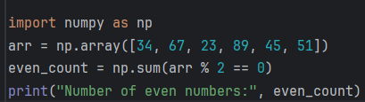

Output:  
Number of even numbers: 1

1. How do you flatten a 2D NumPy array to 1D?

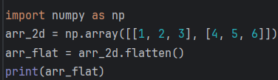

Output:  
[1 2 3 4 5 6]

1. Create an array of 10 random floats between 0 and 1.

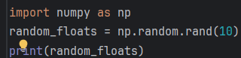

Output:  
[0.64704972 0.37286703 0.06165399 0.25519434 0.05076396 0.70420869

0.80208195 0.06449892 0.80554026 0.69564338]

1. Multiply two NumPy arrays element-wise.

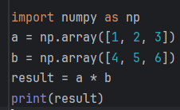

Output:  
[ 4 10 18]

1. Given a NumPy array, how do you find the index of the maximum value?

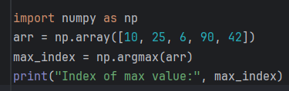

Output:  
Index of max value: 3